Application Deployment — Submission
Deploy the given React application to a production-ready state

1. Key Links & Artifacts
GitHub Repository: https://github.com/NaveenOVN/devops-build-nawin
Deployed Site URL: http://15.207.222.243
Docker Images:
- Dev (public): nawin28/dev:latest (for dev branch)
- Prod (private): nawin28/prod:latest (for main branch)
Branches:
- dev — builds and pushes to react-app-dev, auto-deploys to the app server
- main — builds and pushes to react-app-prod, auto-deploys to the app server

2. Jenkins Screenshot

2.1 Login Page
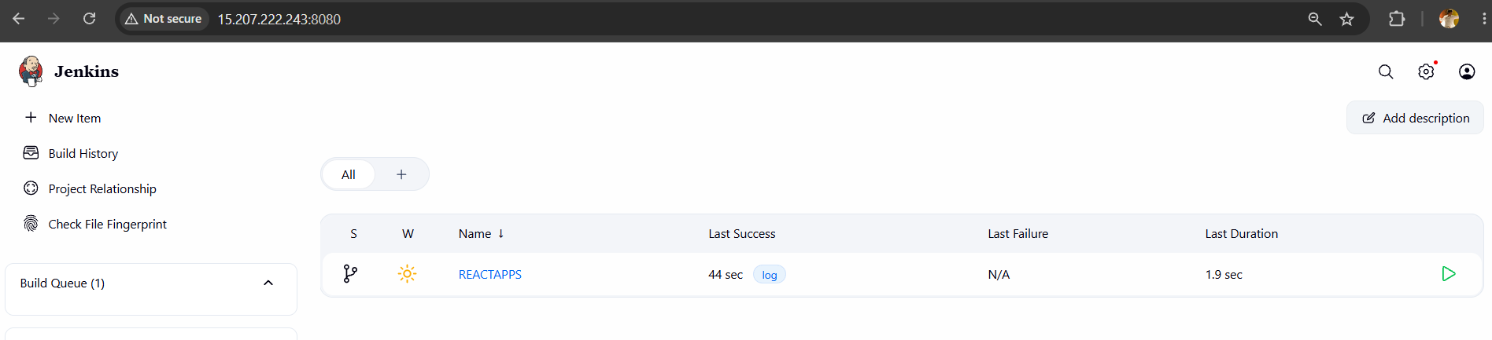

2.2 Configuration Settings
Credentials configured for Docker Hub push access and EC2 SSH access:
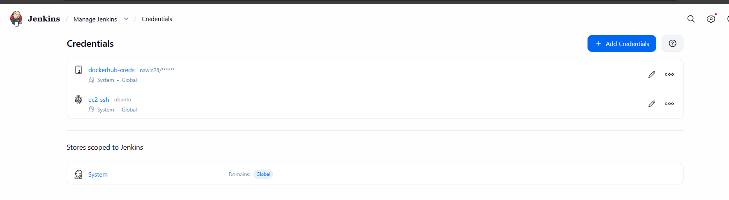
Jenkins → Manage Jenkins → Credentials → Global — github-credentials

2.3 Execute / Build Steps

Branch indexing

> git rev-parse --resolve-git-dir /var/lib/jenkins/caches/git-5e73e66137ff200a1a89006a183f8e9f/.git # timeout=10

Setting origin to https://github.com/NaveenOVN/devops-build-nawin.git

> git config remote.origin.url https://github.com/NaveenOVN/devops-build-nawin.git # timeout=10

Fetching origin...

Fetching upstream changes from origin

> git --version # timeout=10

> git --version # 'git version 2.53.0'

> git config --get remote.origin.url # timeout=10

> git fetch --no-tags --force --progress -- origin +refs/heads/*:refs/remotes/origin/* # timeout=10

Seen branch in repository origin/dev

Seen branch in repository origin/main

Seen 2 remote branches

Obtained Jenkinsfile from 61ead91677127c78f6afdd75699be704eb739c94

[Pipeline] Start of Pipeline

[Pipeline] node

Running on Jenkins in /var/lib/jenkins/workspace/REACTAPPS_dev

[Pipeline] {

[Pipeline] stage

[Pipeline] { (Declarative: Checkout SCM)

[Pipeline] checkout

Selected Git installation does not exist. Using Default

The recommended git tool is: NONE

No credentials specified

> git rev-parse --resolve-git-dir /var/lib/jenkins/workspace/REACTAPPS_dev/.git # timeout=10

Fetching changes from the remote Git repository

> git config remote.origin.url https://github.com/NaveenOVN/devops-build-nawin.git # timeout=10

Fetching without tags

Fetching upstream changes from https://github.com/NaveenOVN/devops-build-nawin.git

> git --version # timeout=10

> git --version # 'git version 2.53.0'

> git fetch --no-tags --force --progress -- https://github.com/NaveenOVN/devops-build-nawin.git +refs/heads/*:refs/remotes/origin/* # timeout=10

Checking out Revision 61ead91677127c78f6afdd75699be704eb739c94 (dev)

> git config core.sparsecheckout # timeout=10

> git checkout -f 61ead91677127c78f6afdd75699be704eb739c94 # timeout=10

Commit message: "Update Jenkinsfile"

> git rev-list --no-walk 7aa2b050ecc7b6727ab36b15fd64d765cd1f23ab # timeout=10

[Pipeline] }

[Pipeline] // stage

[Pipeline] withEnv

[Pipeline] {

[Pipeline] withCredentials

Masking supported pattern matches of $DOCKERHUB or $DOCKERHUB_PSW

[Pipeline] {

[Pipeline] stage

[Pipeline] { (Checkout)

[Pipeline] checkout

Selected Git installation does not exist. Using Default

The recommended git tool is: NONE

No credentials specified

> git rev-parse --resolve-git-dir /var/lib/jenkins/workspace/REACTAPPS_dev/.git # timeout=10

Fetching changes from the remote Git repository

> git config remote.origin.url https://github.com/NaveenOVN/devops-build-nawin.git # timeout=10

Fetching without tags

Fetching upstream changes from https://github.com/NaveenOVN/devops-build-nawin.git

> git --version # timeout=10

> git --version # 'git version 2.53.0'

> git fetch --no-tags --force --progress -- https://github.com/NaveenOVN/devops-build-nawin.git +refs/heads/*:refs/remotes/origin/* # timeout=10

Checking out Revision 61ead91677127c78f6afdd75699be704eb739c94 (dev)

> git config core.sparsecheckout # timeout=10

> git checkout -f 61ead91677127c78f6afdd75699be704eb739c94 # timeout=10

Commit message: "Update Jenkinsfile"

[Pipeline] }

[Pipeline] // stage

[Pipeline] stage

[Pipeline] { (Build Docker Image)

[Pipeline] script

[Pipeline] {

[Pipeline] sh

+ docker build -t nawin28/dev:latest .

DEPRECATED: The legacy builder is deprecated and will be removed in a future release.

Install the buildx component to build images with BuildKit:

https://docs.docker.com/go/buildx/

Sending build context to Docker daemon 3.654MB

Step 1/4 : FROM nginx:alpine

---> 72ba65eb42c1

Step 2/4 : COPY build /usr/share/nginx/html

---> Using cache

---> eac52edea4ce

Step 3/4 : EXPOSE 80

---> Using cache

---> 01a6cdfd5b70

Step 4/4 : CMD ["nginx", "-g", "daemon off;"]

---> Using cache

---> efea9cc033b1

Successfully built efea9cc033b1

Successfully tagged nawin28/dev:latest

[Pipeline] }

[Pipeline] // script

[Pipeline] }

[Pipeline] // stage

[Pipeline] stage

[Pipeline] { (Push to Docker Hub)

[Pipeline] script

[Pipeline] {

[Pipeline] sh

Warning: A secret was passed to "sh" using Groovy String interpolation, which is insecure.

Affected argument(s) used the following variable(s): [DOCKERHUB_PSW]

See https://jenkins.io/redirect/groovy-string-interpolation for details.

+ echo ****

+ docker login -u nawin28 --password-stdin

Login Succeeded

+ docker push nawin28/dev:latest

The push refers to repository [docker.io/nawin28/dev]

afac06e4c3f7: Waiting

55afa1ecc21d: Waiting

51900e10fb9c: Waiting

850bf2dcecff: Waiting

af7dd138f459: Waiting

58c524ea09ce: Waiting

bc98d7675616: Waiting

8f924cf5086c: Waiting

6636b9fc203c: Waiting

bc98d7675616: Waiting

8f924cf5086c: Waiting

6636b9fc203c: Waiting

afac06e4c3f7: Waiting

55afa1ecc21d: Waiting

51900e10fb9c: Waiting

850bf2dcecff: Waiting

af7dd138f459: Waiting

58c524ea09ce: Waiting

58c524ea09ce: Waiting

bc98d7675616: Waiting

8f924cf5086c: Waiting

6636b9fc203c: Waiting

afac06e4c3f7: Waiting

55afa1ecc21d: Waiting

51900e10fb9c: Waiting

850bf2dcecff: Waiting

af7dd138f459: Waiting

8f924cf5086c: Waiting

6636b9fc203c: Waiting

afac06e4c3f7: Waiting

55afa1ecc21d: Waiting

51900e10fb9c: Waiting

850bf2dcecff: Waiting

af7dd138f459: Waiting

58c524ea09ce: Waiting

bc98d7675616: Waiting

bc98d7675616: Waiting

8f924cf5086c: Waiting

6636b9fc203c: Waiting

afac06e4c3f7: Waiting

55afa1ecc21d: Waiting

51900e10fb9c: Waiting

850bf2dcecff: Waiting

af7dd138f459: Waiting

58c524ea09ce: Waiting

850bf2dcecff: Waiting

af7dd138f459: Waiting

58c524ea09ce: Waiting

bc98d7675616: Waiting

8f924cf5086c: Waiting

6636b9fc203c: Waiting

afac06e4c3f7: Waiting

55afa1ecc21d: Waiting

51900e10fb9c: Waiting

850bf2dcecff: Waiting

af7dd138f459: Waiting

58c524ea09ce: Waiting

bc98d7675616: Waiting

8f924cf5086c: Waiting

6636b9fc203c: Waiting

afac06e4c3f7: Waiting

55afa1ecc21d: Waiting

51900e10fb9c: Waiting

afac06e4c3f7: Waiting

55afa1ecc21d: Waiting

51900e10fb9c: Waiting

850bf2dcecff: Waiting

af7dd138f459: Waiting

58c524ea09ce: Waiting

bc98d7675616: Waiting

8f924cf5086c: Waiting

6636b9fc203c: Waiting

850bf2dcecff: Waiting

af7dd138f459: Waiting

58c524ea09ce: Waiting

bc98d7675616: Waiting

8f924cf5086c: Waiting

6636b9fc203c: Waiting

afac06e4c3f7: Waiting

55afa1ecc21d: Waiting

51900e10fb9c: Waiting

af7dd138f459: Waiting

58c524ea09ce: Waiting

bc98d7675616: Waiting

8f924cf5086c: Waiting

6636b9fc203c: Waiting

afac06e4c3f7: Waiting

55afa1ecc21d: Waiting

51900e10fb9c: Waiting

850bf2dcecff: Waiting

afac06e4c3f7: Waiting

55afa1ecc21d: Waiting

51900e10fb9c: Layer already exists

850bf2dcecff: Waiting

af7dd138f459: Waiting

58c524ea09ce: Waiting

bc98d7675616: Waiting

8f924cf5086c: Waiting

6636b9fc203c: Layer already exists

850bf2dcecff: Waiting

af7dd138f459: Waiting

58c524ea09ce: Waiting

bc98d7675616: Waiting

8f924cf5086c: Waiting

afac06e4c3f7: Waiting

55afa1ecc21d: Waiting

850bf2dcecff: Layer already exists

af7dd138f459: Layer already exists

58c524ea09ce: Waiting

bc98d7675616: Waiting

8f924cf5086c: Waiting

afac06e4c3f7: Waiting

55afa1ecc21d: Waiting

58c524ea09ce: Waiting

bc98d7675616: Waiting

8f924cf5086c: Waiting

afac06e4c3f7: Waiting

55afa1ecc21d: Waiting

afac06e4c3f7: Layer already exists

55afa1ecc21d: Layer already exists

58c524ea09ce: Layer already exists

bc98d7675616: Layer already exists

8f924cf5086c: Layer already exists

latest: digest: sha256:efea9cc033b1658502a77eae9481e3728e4743893263d0a3d6a14d187f049160 size: 2264

[Pipeline] }

[Pipeline] // script

[Pipeline] }

[Pipeline] // stage

[Pipeline] stage

[Pipeline] { (Deploy to EC2)

Stage "Deploy to EC2" skipped due to when conditional

[Pipeline] getContext

[Pipeline] }

[Pipeline] // stage

[Pipeline] }

[Pipeline] // withCredentials

[Pipeline] }

[Pipeline] // withEnv

[Pipeline] }

[Pipeline] // node

[Pipeline] End of Pipeline

Finished: SUCCESS

3. AWS Screenshots

3.1 EC2 Console

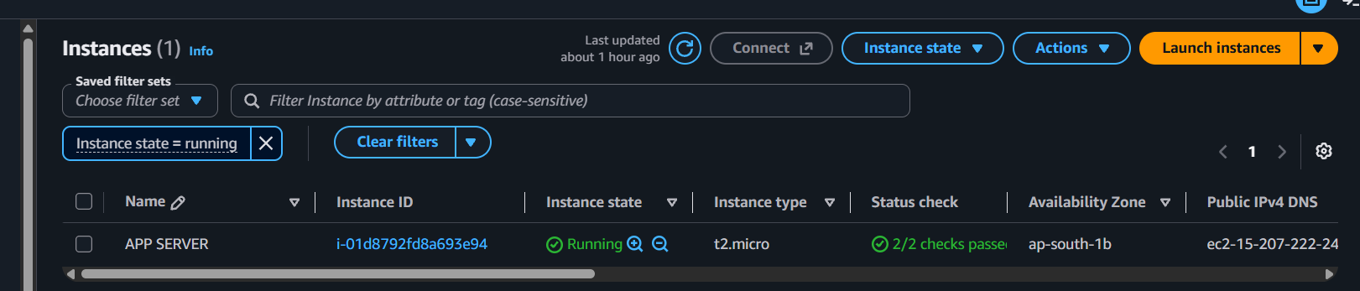

3.2 Security Group Configurations
App server security group — inbound rules (SSH Server login, HTTP browser, Kuma Monitoring port):
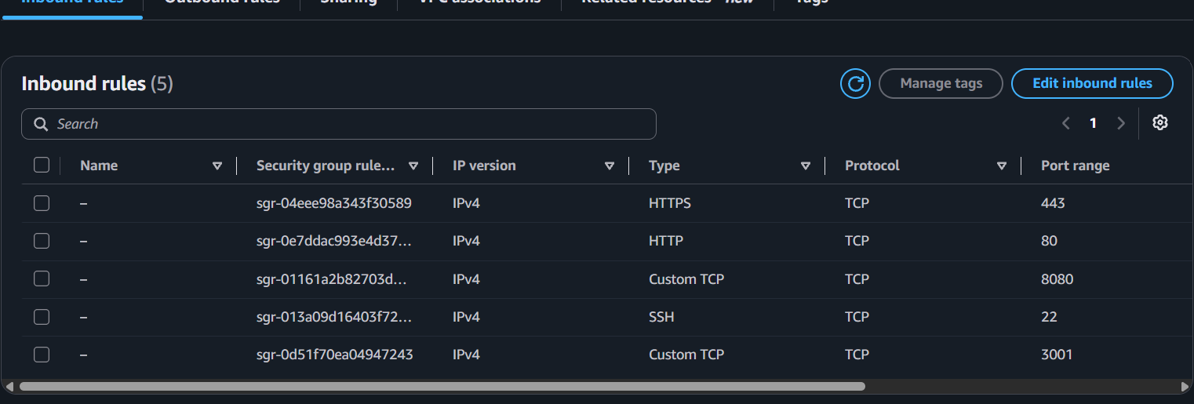

Docker Hub
Docker Hub repo page REACT APP DEV showing image tags (public) ]
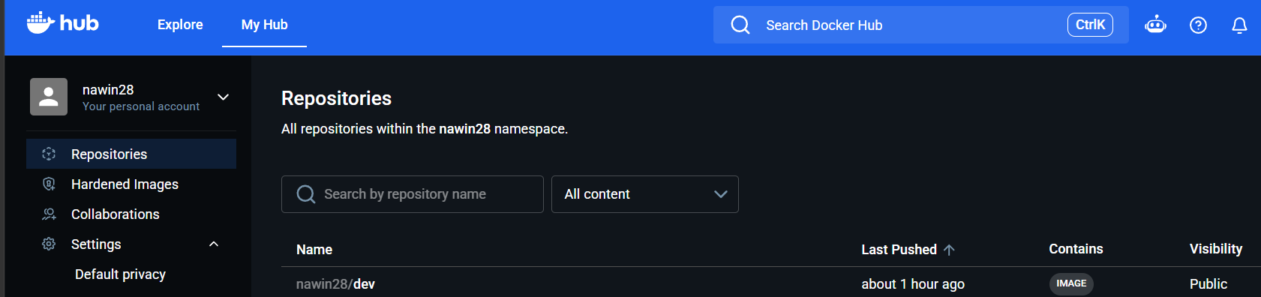
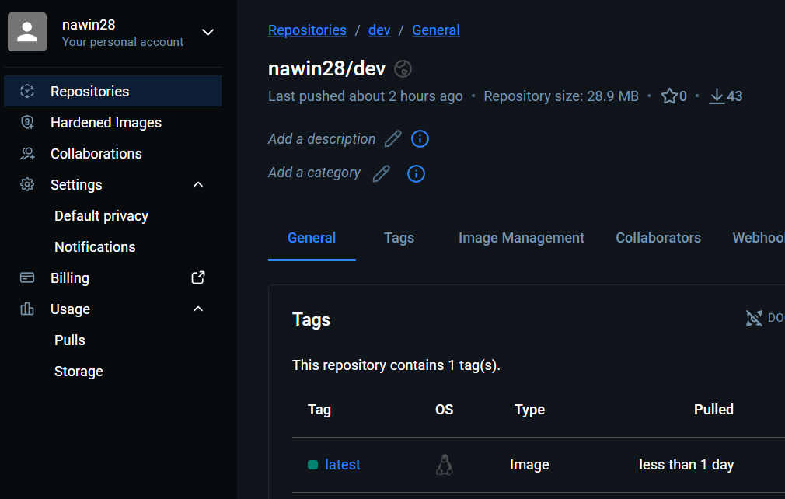

Docker Hub repo page for REACT APP-prod showing image tags (private) ]
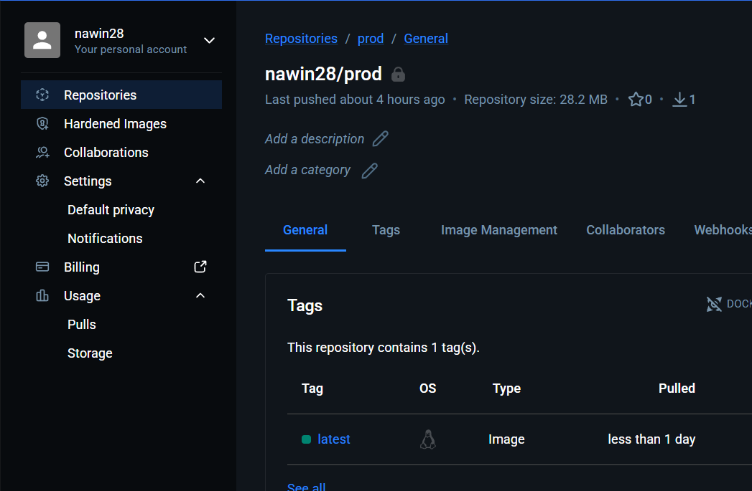

5. Deployed Site
Browser screenshot of the live app at React App 15.207.222.243

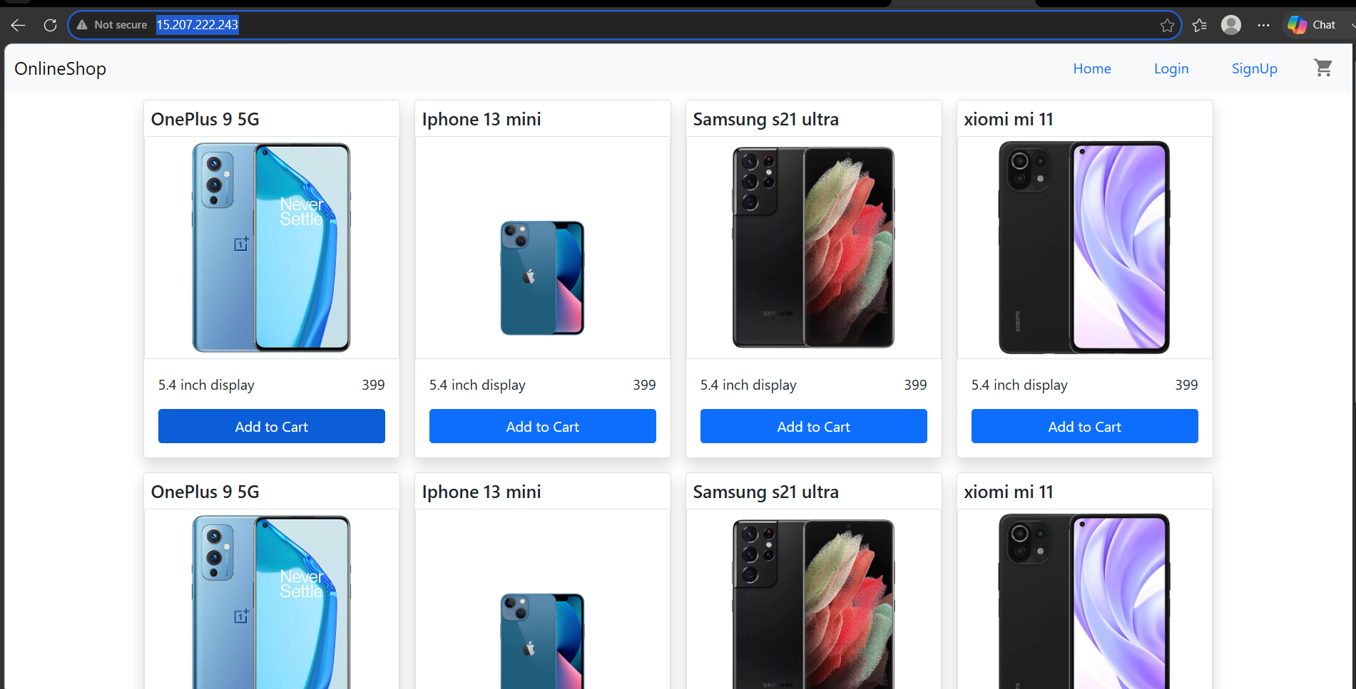

6.Monitoring — Health Check Status
Uptime Kuma dashboard showing the REACT APP monitor status (Up) ]

